Процедура обмена Lan4Tap с сервером Mifare карт.
Обмен между Lan4Tap и сервером обработки Mifare card осуществляется по TCP/IP
(Lan4Tap является TCP клиентом).
Обмен происходит используя:
TCP Command Frame (max size -256 bytes):
1 byte – длина в байтах, следующих далее данных в frame (включ. Command Name byte)
1 byte – Command Name byte (имя команды)
0..N bytes – Command Data (могут отсутствовать для некоторых команд)

Обмен начинается с установки TCP-connect со стороны Lan4Tap и отправки им команды Initialize,
содержащей тип и ID Mifare карты.
Завершение обмена осуществляется посылкой команды Finish от сервера Mifare или разрывом TCP/IP сессии. (пример работы (на Delphi) Mifare Server (для чтения кол-во поездок на карте метрополитена) см. MifareServ.dpr функция ParseRequest_MakeResponse)

Initialize Command: (Command Name byte -‘I’) ( посылается только Lan4Tap)
Command Data:
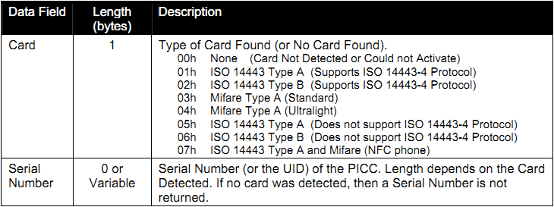

Note: Most cards use a 4-byte UID, so the data field of the response is five (5) bytes long. However, some cards with 7-byte UID’s have entered the market (for example, ViVOcard3) and it is expected that cards with 10-byte UID’s will soon become available. All of these card types are handled by this command.

Finish Command: (Command Name byte -‘F’) ( посылается только сервером Mifare)
No Command Data

Get PCD & PICC Parameters Command: (Command Name byte -‘P’)
This command allows to retrieve PCD and PICC related parameters from the ViVOpay.

Request - No Command Data

Response Data

Get PCD & PICC Parameters Data Field:
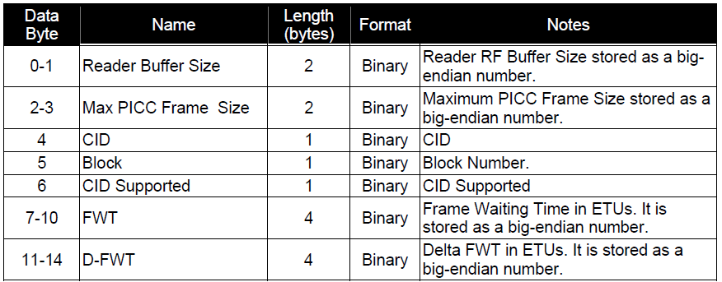 (Bytes) Format Notes

PCD Single Command Exchange (Command Name byte -‘E’)

This command does allow to send, via ViVOpay, raw data to an ISO 14443 PICC that does not support ISO 14443-4 Protocol (such as Mifare Standard or Mifare Ultralight). The PICC response is sent back by ViVOpay.

PCD Single Command Exchange Data Field
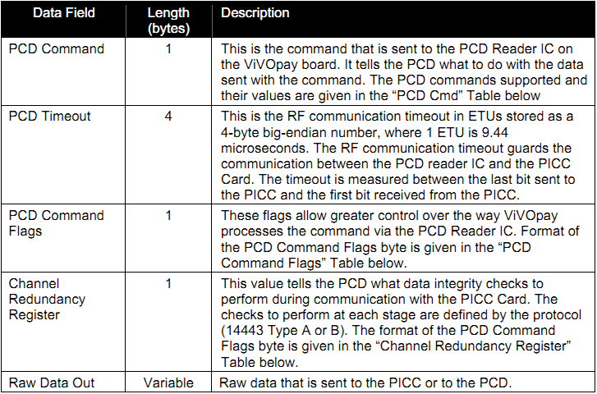

The Command Frame contains some PCD parameters and raw data. The PCD Command Parameter is used by ViVOpay to determine what PCD function is to be carried out. The raw data is sent to the PICC for the Transceive command, or is used for LoadKey / Authentication. The contents of the data depend on the PICC and PCD and are out of the scope of this document.

PCD Commands
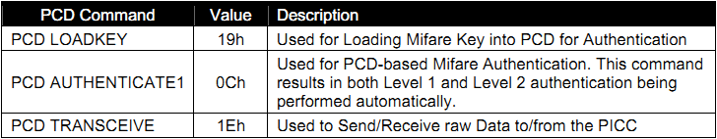

Note: The Load key, Auth1 and Auth2 functions may also be performed by the terminal directly by using the PCD Transceive Command

PCD Command Flags Table
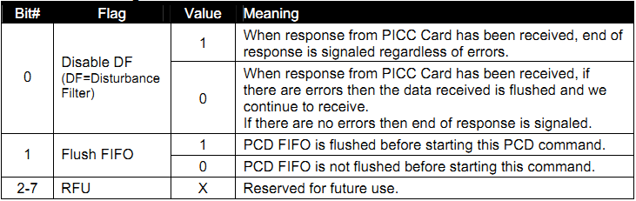

PCD Channel Redundancy Register
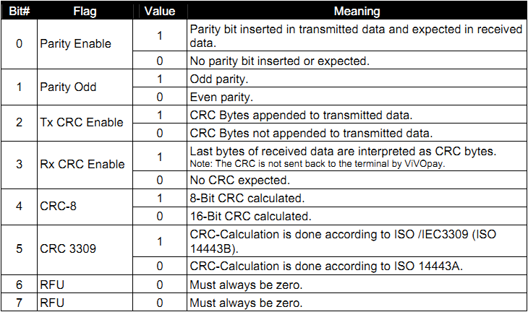
If a valid Command Frame is received from the terminal, ViVOpay sends the data to the PICC (or carry out the appropriate action) and receives its response. ViVOpay treats the response as unknown data and does not try to interpret it. If all goes well, ViVOpay returns a Response Frame with OK Status and the Data received from the PICC (if any). The Response Frame also contains the result of the PCD Command (PCD Status). The PCD Status may indicate success or an Error Code.

If the Command Frame contains any errors, or an error occurred during communication with the PICC (such as PICC removed from the field), then ViVOpay sends a Response Frame with an appropriate Status. No Data is returned in this case.

PCD Single Command Exchange Data Field for Response
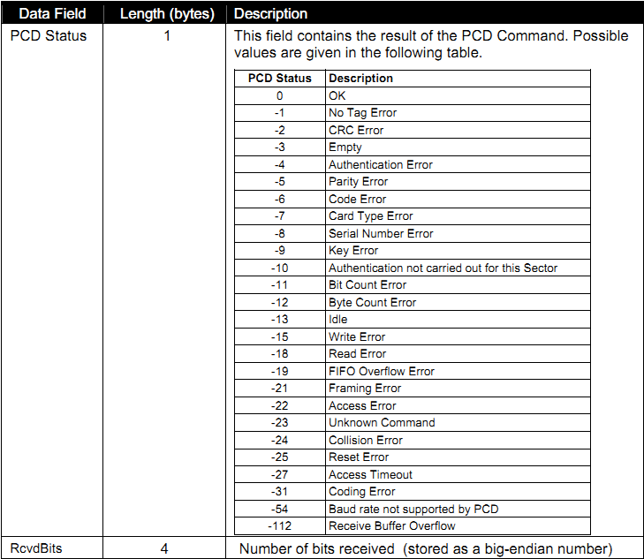

Mifare Read Blocks: (Command Name byte -‘R’)
This command allows the terminal to instruct the ViVOpay reader to read data from one or more blocks on the Mifare Card and return the data to the terminal. The terminal can instruct ViVOpay to read up to 15 blocks using this command. If more than one block is defined, then the reader automatically reads the starting block and the blocks that follow.

The block size depends on the type of Mifare card being accessed. For Mifare Standard Cards the block size is 16 bytes. For Mifare Ultralight Cards the block (page) size is 4 bytes; however each read operation reads 16 bytes of data. When reading Mifare Ultralight cards, BlockCount is taken to mean 16 byte blocks (consisting of 4 4-byte pages each).

For example, if the card is a Mifare Ultralight card, and a read is requested starting at Block 3 and BlockCount is 1 then 16 bytes of data are returned consisting of Page # 3, 4, 5 & 6. And if a read is requested starting at Block 3 and BlockCount is 2 then 16*2=32 bytes of data are returned consisting of Page # 3, 4, 5, 6, 7, 8, 9, and 10.

If the card specified is a Mifare Standard card, then the terminal must have successfully sent at least one “Mifare Authenticate Block” command to the reader for the first block to read.

If the card specified is a Mifare Standard card and the read command specifies a single block read, then the reader tries to read the data regardless of whether the block is a sector trailer block or not.

If the card specified is a Mifare Standard card, and the read is a multi block read, then the reader skips reading the sector trailer blocks that contain the Keys (since the Keys cannot be read). Skipped blocks are not included in the block count. While reading blocks in a Mifare Standard Card, if the read requires access to the next sector, then the ViVOpay reader carries out authentication for this block/sector automatically by using the Key Type and Key Value that were used by the terminal to authenticate the sector for the Starting Block via the “Mifare Authenticate Block” command.

Mifare read Block Data Field
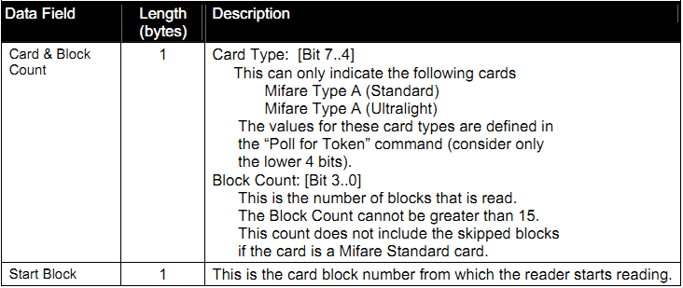

After receiving the Command Frame the ViVOpay reader verifies the parameters. If the parameters are valid, then it reads the data from the card. If this operation is successful, the ViVOpay reader sends a Response Frame containing a Status of OK and the data read. If the operation fails or one or more parameters were invalid, then the reader sends a Response Frame containing an appropriate Status, but no data.

If the Status is OK, then the Data Length depends on the number of blocks read and the card type.
DataLen = Blocks Read * (Bytes per Block for Card).
If there was an error or no data was read, then the Data Length is zero.

Mifare Write Blocks: (Command Name byte -‘W’)
This command allows the terminal to instruct the ViVOpay reader to write data to one or more blocks on the Mifare Card. The terminal can instruct ViVOpay to write up to 15 blocks of data using this command. If more than one block is defined, then the reader automatically writes to the starting block and the blocks that follow.

The block size depends on the type of Mifare card being accessed. For Mifare Standard Cards the block size is 16 bytes. For Mifare Ultralight Cards the block size is 4 bytes.

If the card specified is a Mifare Standard card, then the terminal must have successfully sent at least one “Mifare Authenticate Block” command to the reader for the first block to write.

If the card specified is a Mifare Standard card and the write command specifies a single block write, then the reader tries to write the data regardless of whether the block is a sector trailer block or not.

If the card specified is a Mifare Standard card, and the write is a multi block write, then the reader skips writing to the sector trailer blocks that contain the Keys. Skipped blocks are not included in the block count. While writing blocks to a Mifare Standard Card, if the write requires access to the next sector, then the ViVOpay reader carries out authentication for this block/sector automatically by using the Key Type and Key Value that were used by the terminal to authenticate the sector for the Starting Block via the “Mifare Authenticate Block” command.

Byte 13 Data Length (LSB) is the total length of the full blocks to be written plus 1 byte for the Card & Block Count plus 1 byte for the Start Block. For example, if three 16 byte blocks (30h) are to be written, the Byte 13 Data Length should be 32h (Data to be written 30h + Card & Block Count 01h + Start Block 01h).

Mifare Write Block Data Field
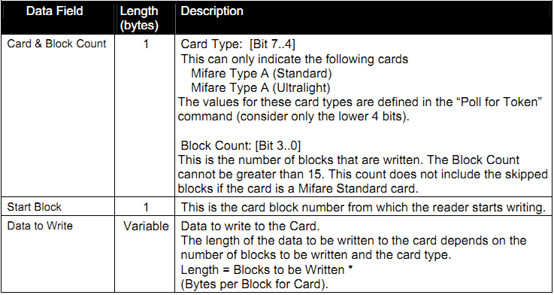

After receiving the Command Frame the ViVOpay reader verifies the parameters. If the parameters are valid, it writes the data to the card. If this operation is successful, the ViVOpay reader sends a Response Frame with a Status of OK.

If the Command Frame is invalid or the write operation fails then the reader sends a Response Frame with an appropriate Status.

Mifare Authenticate Block: (Command Name byte -‘A’)

This command allows the terminal to instruct the ViVOpay reader to authenticate the Mifare Card sector containing the specified block of data. The Key to be used is also specified by the terminal. This command is applicable only for Mifare Standard / Classic Cards. It is not applicable for Mifare Ultralight Cards.

Mifare Authentication Block Data Field
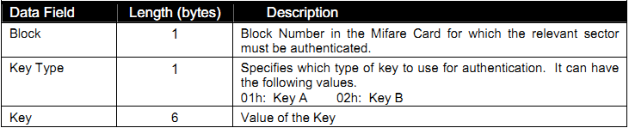

For details on these fields, refer to the relevant Mifare Specifications

After receiving the Command Frame, the ViVOpay reader verifies the data and if the data is valid, then interacts with the Mifare card to authenticate the sector containing the specified block. If this operation is successful, the ViVOpay reader sends a Response Frame with an OK Status. If the operation fails or the data was invalid, then the reader returns a Response Frame with an appropriate Status.

Glossary

PICC - ISO 14443 Type A or Type B Proximity Card
PCD - Proximity coupling device

